**Qualitative Modeling of Aircraft Geometries for Comparison with Numerical Methods**

Joel Lubinitsky

John F. Dannenhoffer, III

*Aerospace Computational Methods Laboratory*

*Syracuse University*

Computer aid design is often a critical component of communication throughout the development process. With CAD packages capable of performing various complex analyses, this software has also become a boon to the invention process. Engineering Sketch Pad is one such software package, with capabilities to perform sensitivity analysis of various parameters, oriented primarily toward aircraft. A planned capability of ESP is the ability to use computational optimization methods to generate a geometry based on a set of defined parameters specific to a particular aircraft. However, in order to evaluate the efficacy of these methods and have a point of comparison, some human-built baseline models are necessary. The primary factors to be compared will be the time to build the model and the final goodness of the fit. It is implied, however, that the user generating these baseline geometries has some degree of experience doing so and some understanding of the overall process. This would reduce the time spent for learning and discovery, and ensure that most of the time is spent on tasks relevant to the interest of this research. In order to gain such familiarity with the aircraft modelling process and the methodology involved, a more accessible program, OpenVSP, is used as a precursor. This program is centered primarily on the design of aircraft models for visual purposes. The emphasis of the software is on ease of use, rather than any sort of analysis. After creating these ‘practice’ geometries, they are to be recreated in ESP with its less constrained tools. An additional objective of this project is to document the ESP modelling process to create a tutorial for the construction of an aircraft.

Beginning with OpenVSP, several basic models were created to gain some familiarity with the overall process. The models to be designed were chosen from three separate categories of aircraft; commercial, general aviation, and fighter aircraft. The first designed was the Boeing 747-400. This was chosen as it had a relatively consistent fuselage shape, which required very few cross sections to be blended across its length. This was also a very conventional shape with many elements that appear in different variations in other aircraft. The second model was the Cessna 182. This model was considerably more difficult than the 747, primarily because its cross-sections were not circular or elliptical, and asymmetrical across the y-axis for the most part. For the last part of the process involving OpenVSP, the F16 Fighting Falcon was chosen to be modelled. The primary reason for this choice was its unconventional shape and components, making for a more challenging and meaningful build. These features included the very narrow front, with a much bulkier mid to rear section, as well as an oddly shaped air intake. This final model was the most interesting and provided for the most varied data on build structures, so it was chosen to be the model of primary focus throughout the entire research process. Below is the final version of the F16 as constructed in OpenVSP:

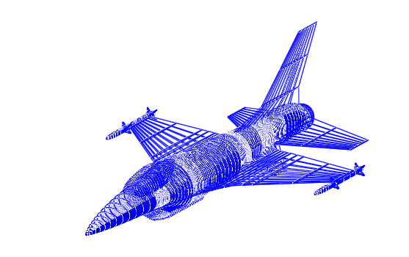

F16 Fighting Falcon, built in OpenVSP

Shifting to ESP, there were some issues determining what base geometries were best to build upon to make the primary structures. This was not a problem in OpenVSP because parts were predefined and constrained to involve only the parameters relevant to that component. In ESP, much of construction involved creating basic shapes and points, performing various transformations on them, and then using a function such as ‘blend’ to create a solid figure. This, among other methods, was borrowed from the prebuilt methodology of OpenVSP. There were considerably more steps involved, however. Where elements in OpenVSP were defined with respect to each other within an individual part, elements in ESP must all be defined from the origin. Below is an example of one such process, involving the construction of the wings. 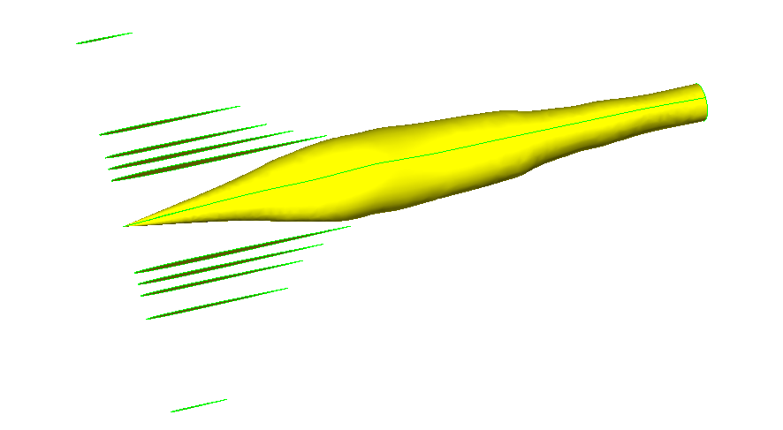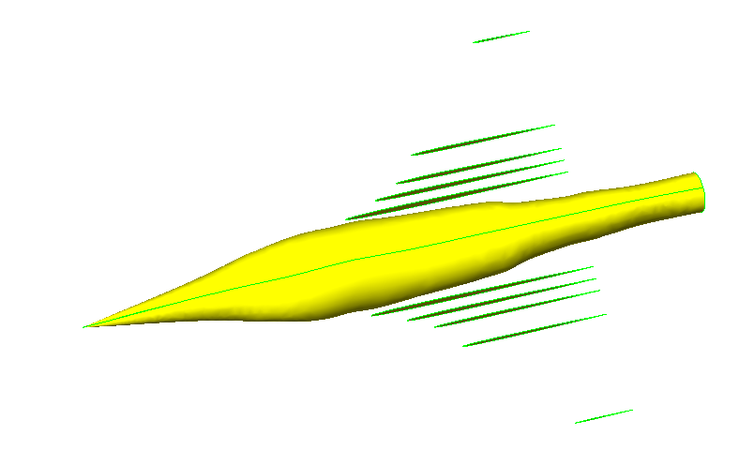

Sections translated along x-axis away from the nose

Airfoil cross-sections translated along y-axis

The result of the ESP build, while still in need of some finishing touches, appears as follows:

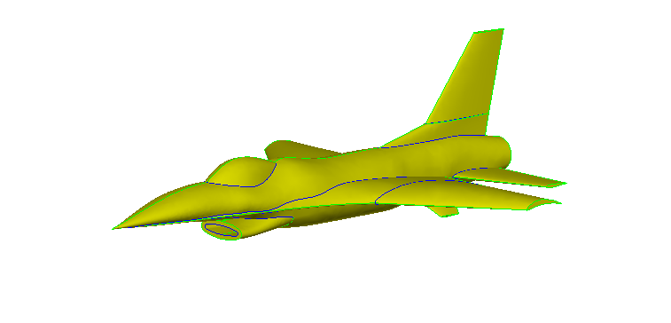

F16 Fighting Falcon, built in ESP

The results of the builds are slightly different, primarily because the way the two programs blend cross-sections is different and because of certain difficulties encountered with the differing methodologies of the programs. The time spent for each model varies considerably because of these differences. To build the F16 in OpenVSP took approximately 8-10 hours total. Without the time spent working through issues and learning about the program, a rebuild would likely take about half that time; somewhere between 4-5 hours. A similar build in ESP took substantially longer, clocking in at over 20 hours to build the first time. However, since this was the first and only build in ESP, the time spent learning for this model was much longer. Therefore, the rebuild time would likely be less than half of the original; somewhere around 7-8 hours. Goodness of fit for this model can only be estimated visually at this point. Detailed data of the structure of the aircraft is publicly unavailable, so the accuracy of the model can only be as good as the vision of the builder. In order to build a more accurate model, the specific parameters would need to be known. However, this is a must for the computational method of building the model. This means that when specific dimensions are unavailable, user input is the preferred and only way to generate a model.

While the baseline time and fit can be gathered from this research, no conclusions can be drawn from it as of yet since its objective is reliant on parallel research into computational methods for generating similar models, which is far more time complicated and involved. For this reason, there is no point of comparison for these final figures as of yet, although the results of this research will await their use in evaluating the other, ongoing research.